Table of Contents
1 Project Management Approach 1
1.1 Management Processes and approach 1
1.2 Management Controls 3
1.3 Project plan 5

Project Management

Project Management Approach

Management Processes and approach
EKAGRA’s project management approach and processes are based on industry best practices. The development approach is based on the Unified Process, iterative development and is applied in software development processes. The iterative approach controls the architectural and business risks on the project and provide clear visibility into all aspects of the project.

EKAGRA also uses some techniques from Agile development concepts. Both concepts are characterized by rapid development of well defined small increments (iterations) and are suited for multitude of development tasks. The commercially branded Unified Process implementation can be a large, comprehensive method with heavy overhead activities. EKAGRA typically uses only the components that help the development teams such as the use of automated tools to assist in generating useful and maintainable documentation.

The Unified Process method uses the concept of core workflows repeated multiple times with different emphasis over the course of the project. The core activities of the Unified Process are: Requirements, Analysis, Design, Implementation, and Testing. EKAGRA has added the explicit workflows for Planning, Deployment and Evaluation to harmonize the software activities with the overall project management approach.

Core workflows | Typical activity and deliverables
Planning | Project plan and resources, iteration planning, vision document
Requirements | Scope documents, business function and models, system features, Business Use Cases, architecture constraints
Analysis | Detailed system use cases, other specifications, analysis models, software architecture, GUI design
Design | Detailed design, Activity models, data models, system flows, system interfaces
Implementation | Coding, code units integration
Test | Test plans, test cases, unit testing, integration testing, system testing, and regression testing of previous iterations
Deploy | Prepare production environment, schedule, announce and execute deployments and conversion activities
Evaluate | Lessons learned, features not implemented, defects to be corrected, process and personnel adjustments if needed

Appropriate activities and emphasis are used, for each iteration, to make sure that the management and development workflows are followed. Following sections will illustrate the use of the method and approaches.

<<< Diagram needs to be made generic >>>>
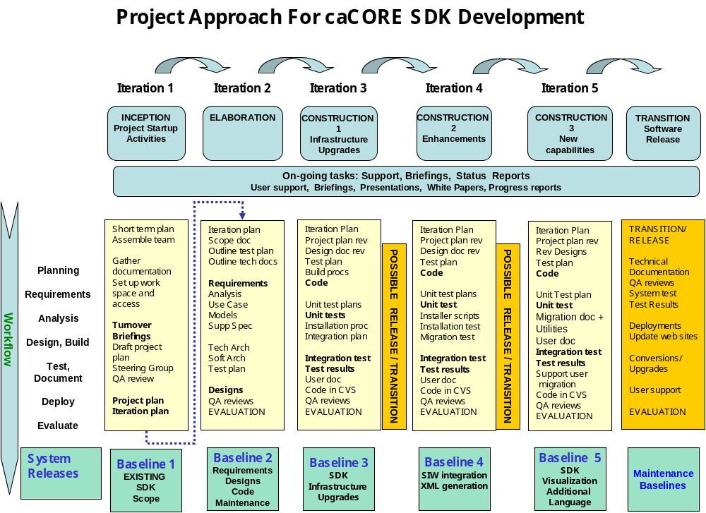

Project Scope Management
Early in the project’s release cycle EKAGRA team members work with customer management and users to define the scope for the development of the task. This process starts out as defining the features in broad terms. While working with customer management and the user community, the EKAGRA team will document detailed features in the initial scope document and then further refine them in an iterative development approach. In addition to the planned features, this scope document will concisely define acceptance criteria, high level milestones and deliverables in terms of business needs. As defined in the project plan section, the scope of the project will be based on the overall project plan that customer organization may be using.

The scope document may identify new or additional dependencies and other potential co-developers (or contributors) to ensure that those cross-team dependencies are coordinated and managed very early in the process. The EKAGRA project manager will outline each major task in the scope document that describes the deliverables. Once the scope, deliverables, roles and boundaries are agreed on with the customer management, the draft project plan and schedule will be revised.

This process of scope management early in the product development life cycle is one of the keys to success for EKAGRA to meet its deadlines. Agreed scope document allows EKAGRA team to effectively manage changes that occur during the software development lifecycle.

Figure 1: Summary of Iterative Approach

Project Planning
EKAGRA project planning first entails the development of a work breakdown structure (WBS). Then the project manager produces a projected schedule, resources, and internal and external dependencies for that WBS. EKAGRA manager uses MS Project (or Excel on smaller tasks) as the project scheduling and control tool. The tool will be used to record activities, assign resources, milestones and monitor the status of tasks. Project manager will ensure that the cross-team and external dependencies are clearly identified in the project plan and on the MS Project schedule to allow for effective management of these dependencies.

The project schedule contains major milestones for deliveries and coordination for the project horizon. More detailed activities are added for each iteration. The detailed activities are included on a rolling horizon basis, typically 2 to 3 months to minimize the overhead of maintaining a very detailed plan over a long horizon. All other major activities and milestones may be in the plan for the entire task.

The EKAGRA project manager works with the existing and potentially new teams, as needed, to gather requirements, develop, design, and deliver an integrated product. The plan includes the following coordination tasks and milestones:
- EKAGRA will request and review the latest development plans of the other teams
- EKAGRA will analyze the requirements and designs for all planned changes
- EKAGRA will reconcile the development plans with the EKAGRA proposed plan
- EKAGRA will submit the proposed plan to the customer management
- While formal coordination is necessary to ensure overall product management and delivery is successful, EKAGRA recognizes that frequent informal interchanges will be critical to deliver integrated products on a timely basis and will ensure that the EKAGRA team is in constant communication with all other participating teams as well as customer management.

Delivery Process
EKAGRA applies structured techniques to make complex processes easier to implement. In a deliverable based environment it is critical that the process for review and acceptance of a deliverable be defined. EKAGRA’s process is as follows:
- If necessary a scope document is developed by EKAGRA for an early review and approval to confirm the full understanding of the task. The scope document will include templates, format, and page count targets.
- At 30% content completion a draft will be reviewed to ensure that the task is on the right track. This draft will have a portion of the overall work completed to such a state that the reviewer can extrapolate the work and provide direction on the task or deliverable. This undergoes an informal review.
- When 100% of the content is completed (format may still be lacking) the document is reviewed again. This is the draft deliverable that, while not completely finished, allows the customer to provide input and make final changes. It is expected that all changes will be based on this draft. The reviewer should specify what they want changed or require clarifications on specific points (e.g. if you make proposed changes we will accept the deliverable).
- The final deliverable with changes is completed. (changes included or not included with a separate explanation).
- The final version is reviewed and submitted for acceptance by the customer.
- All review periods are time boxed. It is assumed that the review feedback will be provided within five business days. If the feedback is not provided within five business days the artifact is assumed to be accurate to move to the next step in the lifecycle.

Management Controls

Project Execution and Control
At EKAGRA project controls remain simple and unambiguous. Reporting structures is a straight line from the team members to the project manager. The project manager will conduct weekly meeting with the EKAGRA team in the beginning of the week to ensure planned activities for the week are on track and issues related to the weekly activities will be discussed and resolved.

The EKAGRA project manager reviews the project plan then identify and question any major discrepancy for the budgeted resources and schedule. The project plan will also provide the customer with an unambiguous measure of the performance against goals. The project plan will be a living document and the project manager will maintain it throughout the duration of the contract. This plan will act as an instrument for control of schedule, resources, milestones, deliverables, and dependencies. It will also provide concrete evidence of progress throughout the project. Additional quality assurance controls are discussed in the Quality Assurance section, and risk management controls are discussed in the risk management section.

Project Status Reporting and Review
As a corporate policy, each EKAGRA employee is required to submit a weekly status report to their immediate supervisors. This status report records work accomplished for the week and planned activities for the next two weeks. This report also includes issues and potential risks.

As required the project manager consolidate the individual reports into a project level status report each week. The weekly reports will be aggregated and summarized for the monthly report. Weekly and monthly status report will include a risk and issue section that will be managed by the project manager, monitored by EKAGRA management and will be shared with the customer management. The project manager will highlight any variations on the project schedule, budget, and quality from planned. In coordination with the customer management, the project manager will propose necessary changes to the plan and/or take corrective actions. The monthly status report will provide following;

- Activities and accomplishment during the reporting period. These activities will map to the project plan that was approved by the PMO.
- Technical progress reporting
  - Summary of work done and percentage complete.
  - Schedule of activities planned for next reporting period
  - Revised project schedule with estimated and remaining hours to completion
  - Status of contract deliverables
  - Issues and problem areas
  - Risks and possible contingencies measures

Quality Assurance and Quality Management

An EKAGRA QA specialist assigned on the task will be specifically responsible to review all deliverables according the criteria specified in the SOW:

- Accuracy - Work Products shall be accurate in presentation, technical content, and adherence to accepted elements of style. The team will use templates, and the documentation will be tested with the systems.
- Clarity - Work Products shall be clear and concise. Any/All diagrams shall be easy to understand and be relevant to the supporting narrative. Peer reviews will highlight deficiencies in clarity and these deficiencies will be corrected.
- Consistency to Requirements - All work products must satisfy the requirements. The deliverable documents will be checked against the specifications of each task as described in our project plan and task approaches.
- File Editing - All text and diagrammatic files shall be editable by the NCICB. The deliverables will be provided in the electronic format specified by NCICB.
- Format - Work Products shall be submitted in hard copy (where applicable) and in media mutually agreed upon prior to submission. Hard copy formats shall follow any specified directives or manuals. Apart from some review copies and possibly larger volumes for presentations or meetings, most deliverables will be provided in hard copy.
- Timeliness - Work Products shall be submitted on or before the due date specified in project plan. The project and program managers are responsible for timely delivery. Our frequent reviews will catch any slippages and allow for adjustments if needed.

Risk Management
Risks and issue management are explicitly handled by the EKAGRA Project Manager. The risks are recorded and classified according to their potential impact and likely occurrence. The risks that affect the program as a whole will need to be raised and dealt with at the overall program level. The risks that affect this task only will be dealt with by the EKAGRA and the customer team. Each risk identified requires a potential impact analysis and a description of contingency measures. Depending on the risk assessment with the customer, contingency plans and activities may be undertaken.

Risks that are realized become issues and their resolution will be managed actively. It is EKAGRA’s policy to be upfront about risks and issues and aggressively address the problems. Each risk must have a contingency plan or action. Each issue must have a resolution plan. The regular weekly meeting and reports will specifically include the management of risks and issues of the project. Once a risk has become an issue and the action to address it has been authorized, it becomes an activity in the project plan and/or a change request. In either case, the remedial actions are visible and tracked.

Program Reviews
While our project manager is responsible for the timely completion of tasks, our Quality Assurance specialist and the President of our company are also responsible to verify that the project plan and practices proposed in this document are followed. To ensure the successful completion of the planned activities to the customer’s satisfaction, EKAGRA management conducts quarterly reviews and informal monthly reviews. The project manager, technical manager and QA engineer are present during this review. At EKAGRA, QA engineers directly report up to the President of the company and not to the individual project management. This allows for unbiased and independent flow of information. At this review timeliness of the deliverables, risks and mitigation strategies, the project schedules and the issues are reviewed.

Project plan

EKAGRA’s iterative software development methodology is applied to the software development project plan. Higher risk business and technical requirements are planned for earlier iterations. While low risk software development activities are completed in later iterations. EKAGRA’s project plan will use the phases of Inception, Elaboration, Construction and Deployment with potentially multiple iterations in each phase. This approach reduces the risks for the project by allowing the customer to review deliverables early and potentially adjust course during the project.

